LADDER LOGIC 2

**🤖** Chapter 5-2: Basic Instructions in Ladder Logic

Boolean Logic and the DNA of Control

Now that you know what Ladder Logic looks like, it’s time to understand **how it actually decides things**. And that takes us straight into **Boolean logic** — the bedrock of all decision-making in PLCs.

Don’t worry, this isn’t Digital Systems 101 — we’re not breaking out Karnaugh maps or Boolean algebra proofs. We’re just gonna look at the essentials: **AND** and **OR** logic.

**🔲** Boolean Logic in Plain Language

PLC logic is built on simple True/False decisions — like light switches:

* **TRUE (1)** → There's voltage or a condition is satisfied
* **FALSE (0)** → No voltage or the condition isn't satisfied

From this binary setup, we build logic gates. In Ladder Logic, these gates are **not separate components** — they’re created through **how you arrange your rungs and contacts**.

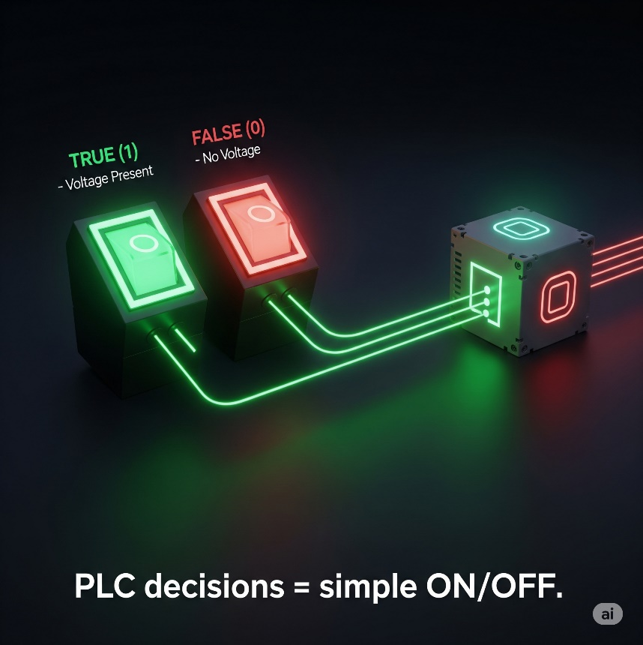

The Gates — Series Logic

🔌 AND gate Ladder Implementation:

**AND** operations are analogous to **multiplication.**

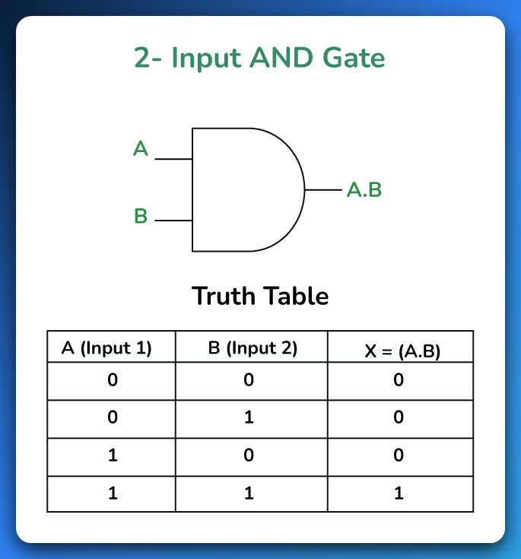

Use **normally open contacts in series**.

This is saying:

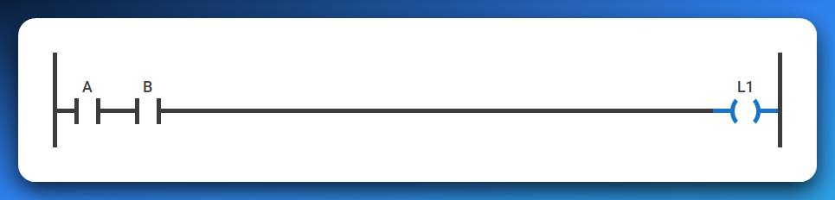

*“Only if A* ***AND*** *B are both TRUE, then turn ON the output.”*

If either A or B is FALSE, current stops flowing — just like if one switch in a series circuit is off.

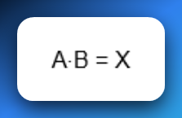

🔌 OR gate Ladder Implementation:  
Use **normally open contacts in parallel**.   
**OR** operations are comparable to **addition**.

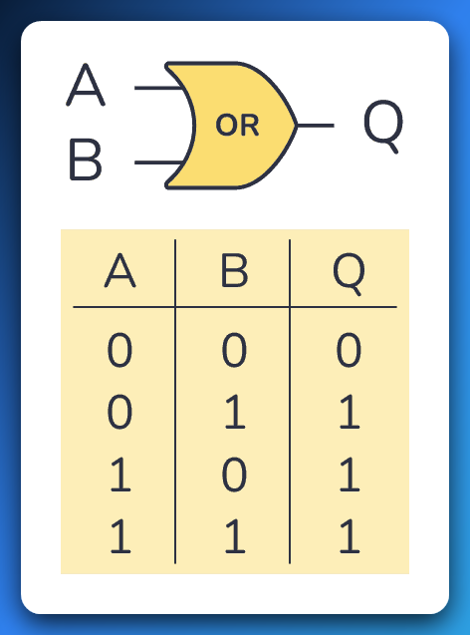

This is saying:

*“If A* ***OR*** *B is TRUE, then turn ON the output.”*

As long as at least one of them is ON, the rung is complete and current flows to the output. 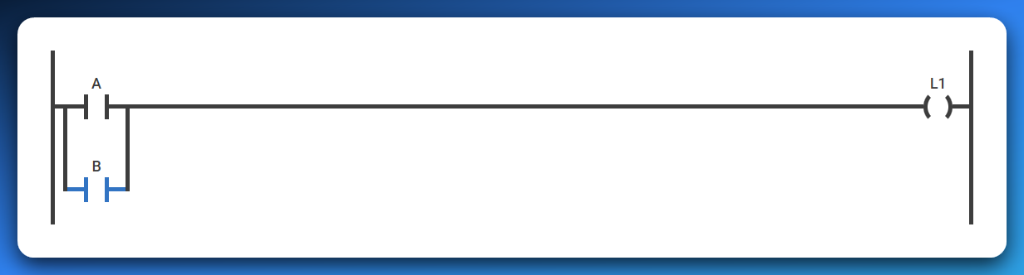

If **A is TRUE** (and B is FALSE), the path through A "closes," allowing logical power to flow to the output.

If **B is TRUE** (and A is FALSE), the path through B "closes," allowing logical power to flow to the output.

If **both A and B are TRUE**, both paths "close," and logical power still flows to the output.

Only if **both A and B are FALSE** will both paths remain "open," stopping the logical power flow and keeping the output OFF.

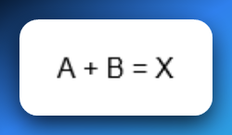

🔌 XOR gate Ladder Implementation:

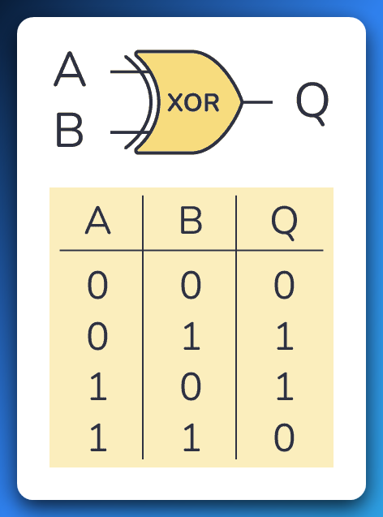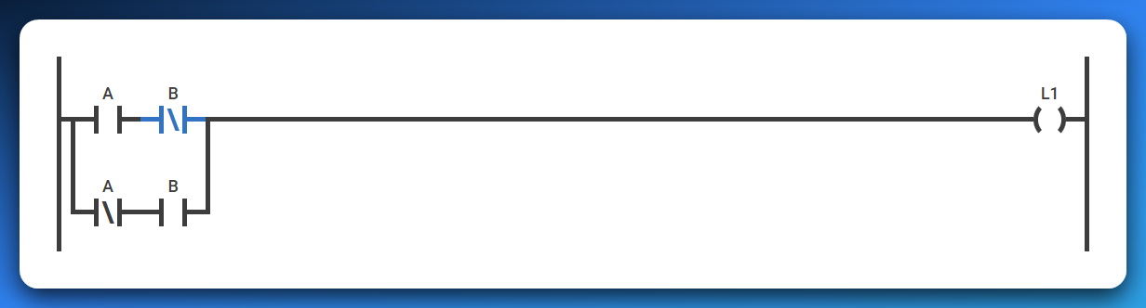

Use a combination of normally open (NO) and normally closed (NC) contacts.  
This represents the logic: **"If A OR B is TRUE, but not both, then turn ON the output."**

**How it works:**

* **If A is TRUE and B is FALSE**:  
  The path through A (NO) and B (NC) closes → Output turns ON.
* **If B is TRUE and A is FALSE**:  
  The path through B (NO) and A (NC) closes → Output turns ON.
* **If both A and B are TRUE**:  
  Both paths are blocked because NC contacts open → Output stays OFF.
* **If both A and B are FALSE**:  
  Neither NO contact allows current → Output stays OFF.

✅ **Summary:** Output is ON **only when A or B is TRUE**, but **not both at the same time** — exactly what XOR logic means.

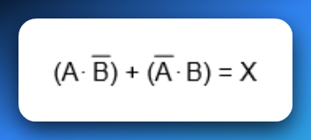

**💡** Key Concept: Contacts Are Logic Conditions

In Ladder Logic, your contacts (—| |—) aren’t checking voltage directly — they’re checking **bit states** in memory.

* A contact in a rung is **like a mini IF-statement**.
* When you place them **in series**, it means “all must be true” (AND).
* When you place them **in parallel**, it means “any can be true” (OR).

And these logic structures determine whether **your output coils (—( )—)** get energized or not.

**🧠** Analogy Time:

* Think of series logic like **security clearance**:  
  “You need both a keycard **and** a password to enter.”
* Think of parallel logic like **alarm triggers**:  
  *“If* ***any*** *of the sensors trip, sound the alarm.”*

**📌** Summary:

* **AND Logic = Series contacts** → All must be TRUE.
* **OR Logic = Parallel contacts** → At least one must be TRUE.
* No separate gate components — it's all about **how you arrange your contacts** in the rung.

The contacts

**🔌** Normally Open (NO) Contact – The “Push‑to‑Start”

Think of a normally open contact like a simple doorbell button.

* **Default (not pressed):** The internal path is open. No current flows. In PLC terms, the memory bit is FALSE (0).
* **When pressed:** The path closes. Electricity flows. In PLC terms, the bit flips to TRUE (1), and logical power can now travel through that rung.

✅ **Analogy:** Press button → bridge closes → current flows → light turns on.

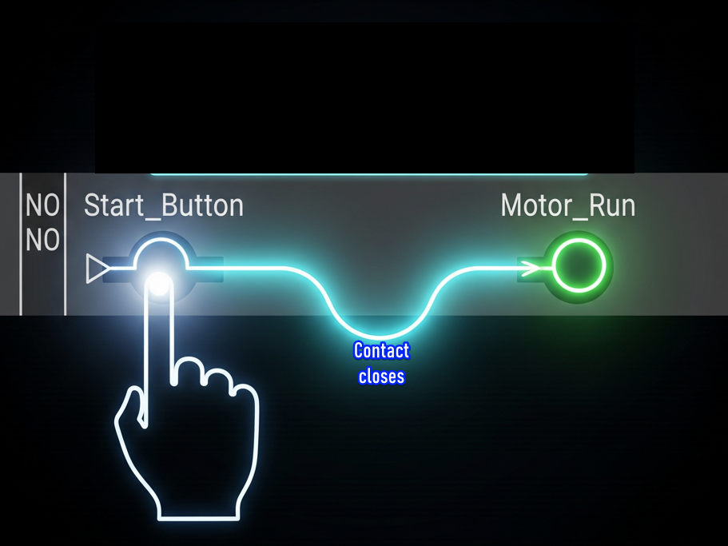

**🛡️** Normally Closed (NC) Contact – The “Safety Gate”

Now flip the logic. A normally closed contact is like a safety gate that’s already allowing current through until you interfere.

* **Default (not pressed):** The path is closed. Electricity flows. In PLC terms, the memory bit is TRUE (1).
* **When pressed:** The path opens. Current stops. In PLC terms, the bit reads FALSE (0), blocking logical power on that rung.

✅ **Analogy:** Press button → bridge opens → no current → light stays off.

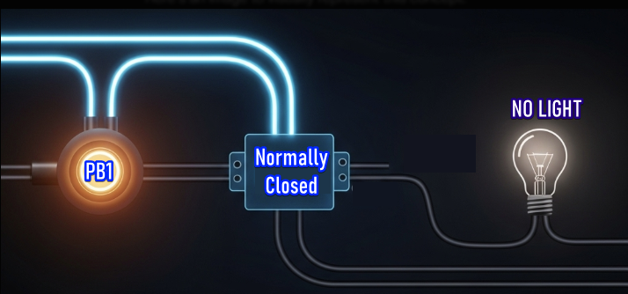

✨ Positive Transition-Sensing Contact ---|P|---

**What it does:** ✅ Fires **only for one scan** when your variable flips from FALSE → TRUE ✅ Think of it as a **one-shot rising edge detector** ✅ It only passes power if the left input is already TRUE at that moment

**Real-world examples:**

* **Start button:** Press to start a machine → you want it to start once, not keep trying to start every scan while held down.
* **Part counter:** When a sensor first detects a part → increment counter once, not continuously while the part passes by.
* **Door opening:** When a door switch goes from closed to open → log one "door opened" event, not hundreds while it stays open.
* **Emergency reset:** After fixing an alarm → acknowledge it once when the reset button is pressed, not repeatedly.

**Why it's essential:** Without this, holding a button would flood your system with repeated commands every scan cycle (potentially thousands of times per second), causing chaos in counters, alarms, and sequences.

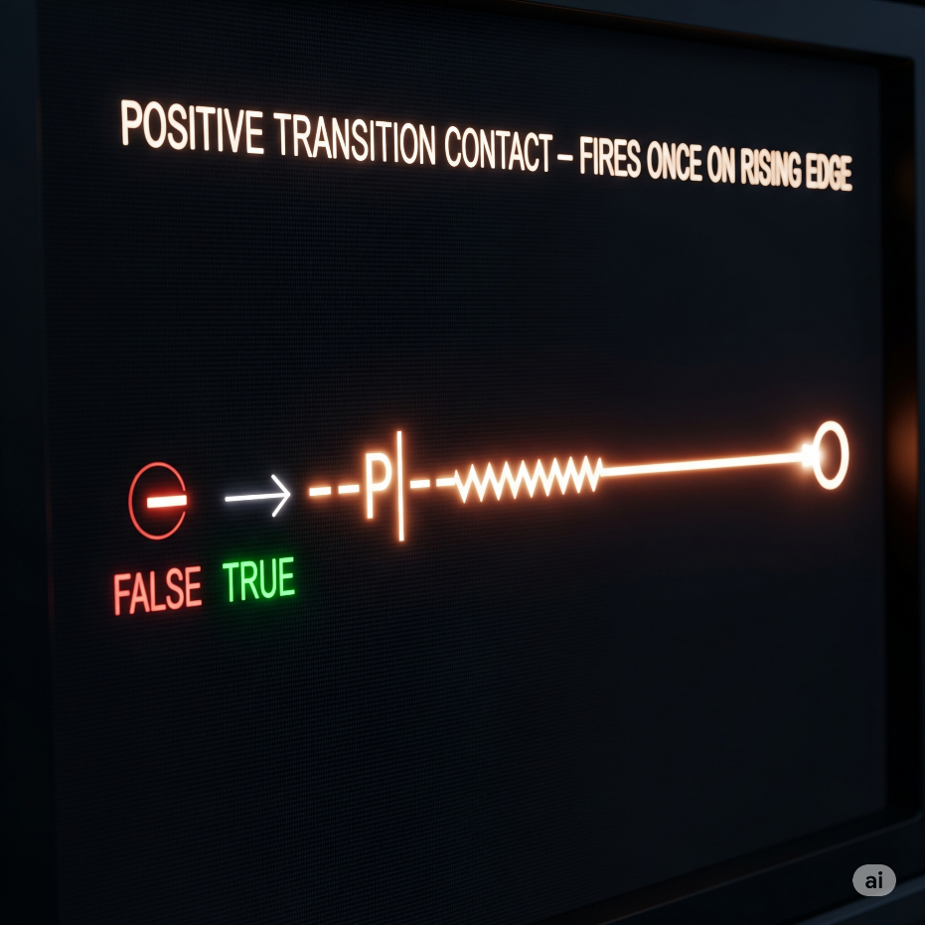

✨ Negative Transition-Sensing Contact ---|N|---

**What it does:** ✅ Fires **only for one scan** when your variable flips from TRUE → FALSE ✅ A **one-shot falling edge detector** ✅ Left input must be TRUE at that moment too

**Real-world examples:**

* **Conveyor control:** When a box leaves the sensor → start the next conveyor section once, not continuously while the sensor is empty
* **Safety logging:** When an emergency stop is released → log one "system restored" event at the exact moment of release
* **Production tracking:** When a part exits the work station → trigger completion counter once as it leaves, not while the station stays empty
* **Door security:** When a door closes → send one "door secured" signal to the alarm system, not constant signals while it stays closed
* **Process completion:** When a tank empties (level sensor goes FALSE) → start the refill cycle once at that instant

**Why it's crucial:** This catches the exact moment something stops or leaves, preventing your system from missing the transition or triggering multiple times. Perfect for "cleanup" actions that should happen right when something ends.

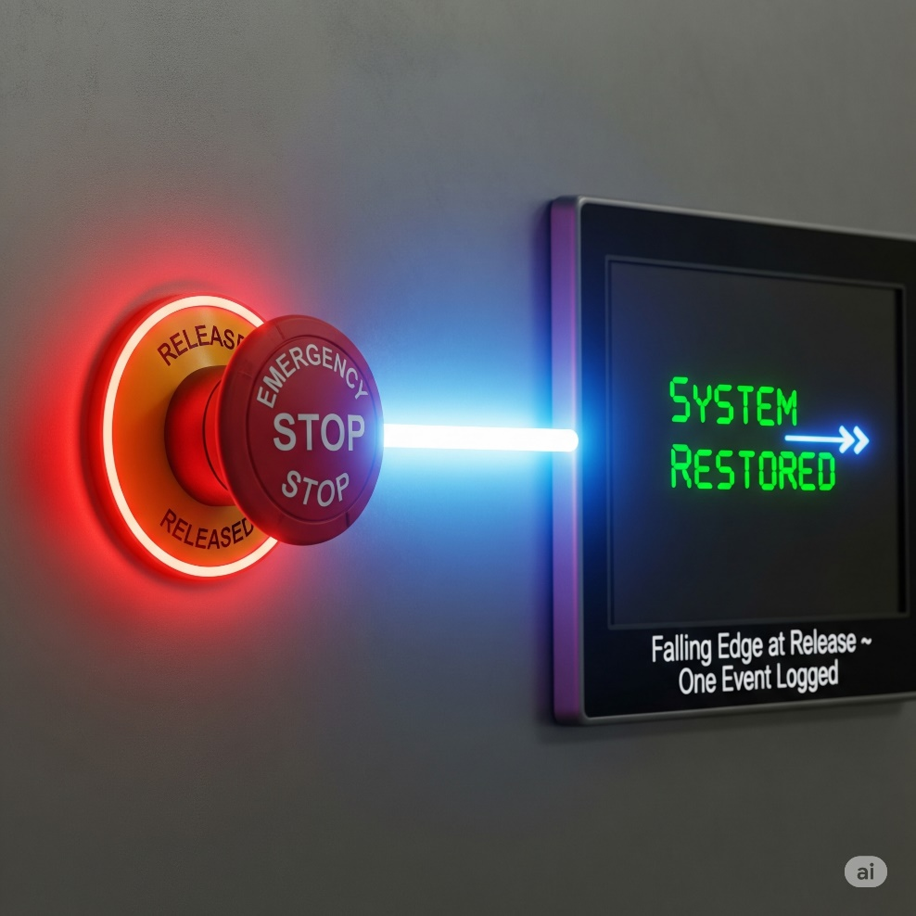

**🌩** OTE (Output Energize)

Think of OTE as the **"result"** of your ladder logic rung. It's what actually happens when all your conditions are met.

**Simple analogy:** You know how a regular light switch works? You flip it up → light turns on. You flip it down → light turns off. OTE is exactly like that light bulb, but instead of a physical switch, it's controlled by the logic you build.

**How it really works:** Every time the PLC scans your program (thousands of times per second), it checks: "Are all the conditions on this rung TRUE right now?"

* If YES → OTE energizes (turns ON)
* If NO → OTE de-energizes (turns OFF)

**Real-world example:** Imagine an automatic parking garage gate:

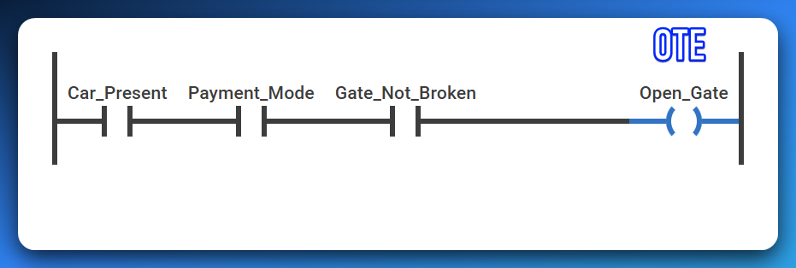

* Car sensor detects a vehicle AND payment was received AND gate isn't broken → gate opens
* Missing any one condition (no car, no payment, gate broken) → gate stays closed
* The gate follows these conditions in real-time - if payment expires while the car is there, gate closes immediately

**Key point:** OTE has zero memory. It's like a faithful dog - it does exactly what you tell it, when you tell it, every single scan. No thinking, no remembering yesterday, just pure obedience to your current logic.

**The OTE (Open_Gate) is like the "DO IT!" command at the end of the line.** When everything to the left of Open_Gate is TRUE (like, all the green lights are on and the vibes are right), then Open_Gate gets powered up, and it stays on as long as those conditions are met.

💡 Bottom line:

NO let’s power through *when active.* NC stops power *when active.*

Together, they’re the Lego blocks of ladder logic—defining exactly when your rungs conduct or block logical “power.”

Simple, powerful, and everywhere in your PLC world.

A PLC.

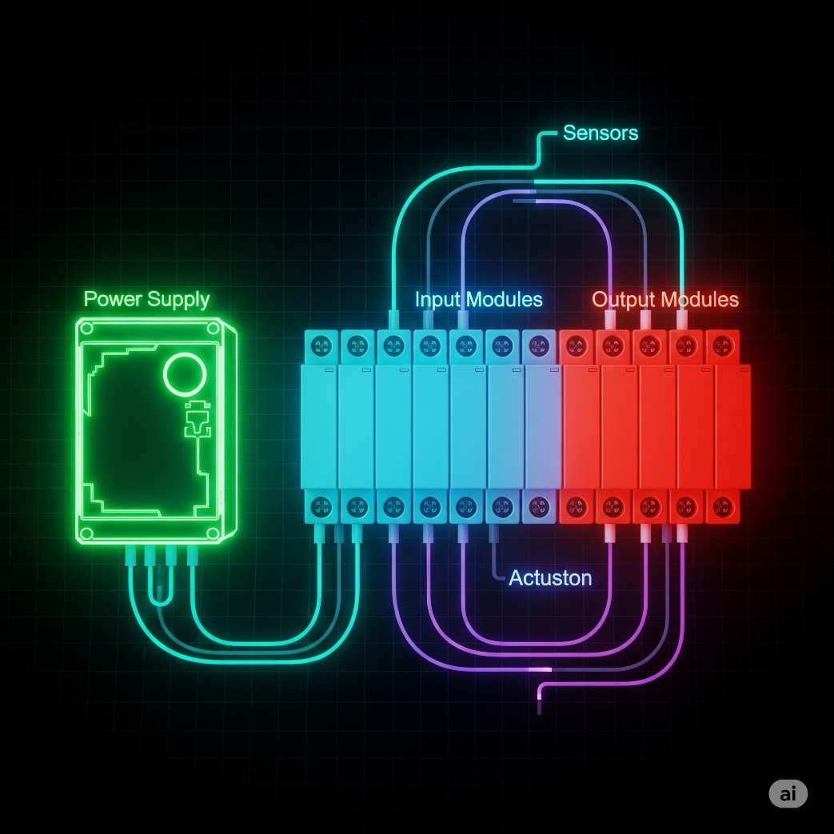

By now we’re good to go forward with this topic.

LADDER LOGIC PART 3

Elements of ladder logic

* **Rails** – Vertical lines that carry electrical power to the control circuit.
* **Rungs** – Horizontal lines where the logic is built; they contain inputs, outputs, and branches.
* **Branches** – Parallel paths on a rung that allow multiple input conditions.
* **Inputs** – Devices like switches or sensors that control the logic flow.
* **Outputs** – Devices like motors or lights activated by the logic.
* **Timer** – Delays actions for a set time (e.g., turn on a light after 5 seconds).
* **Counter** – Counts events or cycles and triggers actions after a set number.

I see a small naming confusion I have always had.

In my school, we used “Ladder Logic” to refer to the programs we were drawing.

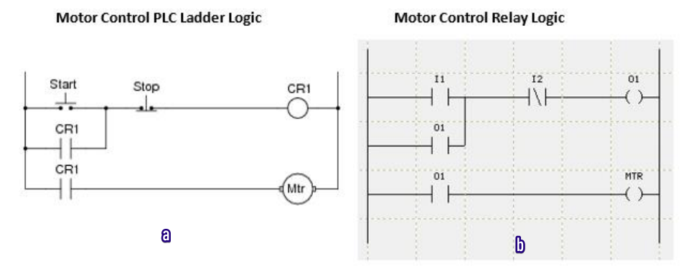

So, I had this conflict calling the **image b** ladder logic.   
Now am seeing it being called **relay logic.**

* **Diagram 'a' (Motor Control PLC Ladder Logic):** This is a **program** that runs inside a PLC. It's software.
* **Diagram 'b' (Motor Control Relay Logic):** This is a **wiring diagram** for physical electrical components (relays, switches, motor). It's hardware.

Some Practice

Y = (X1+X2)X3

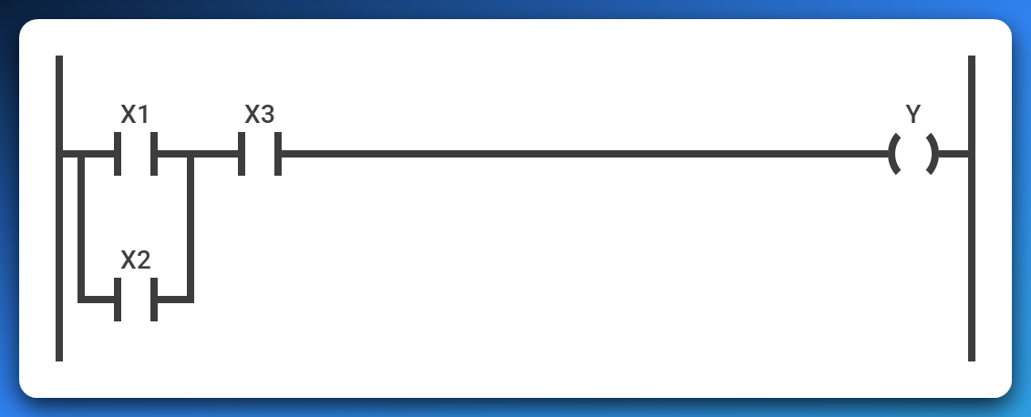

Read it using the AND, OR gates.

Y=(X1+X2)(X3+X4)

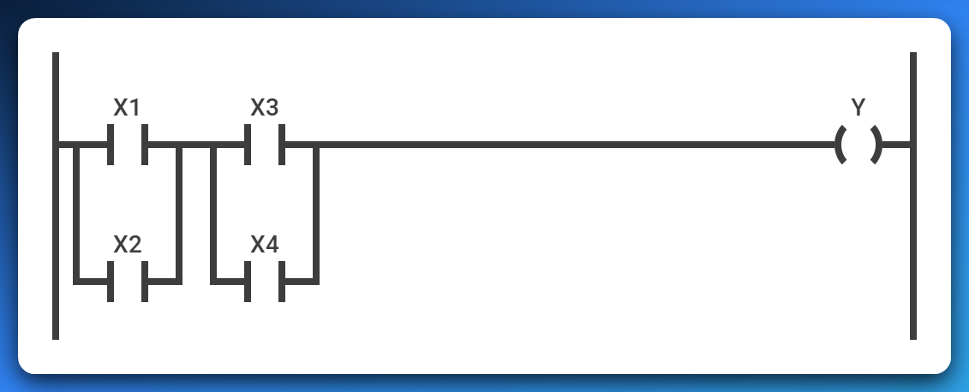

You could attach the midpoint lines as one, or separate them as above.

Y= (X1X2) + X3

